# Nest a Subquery in FROM

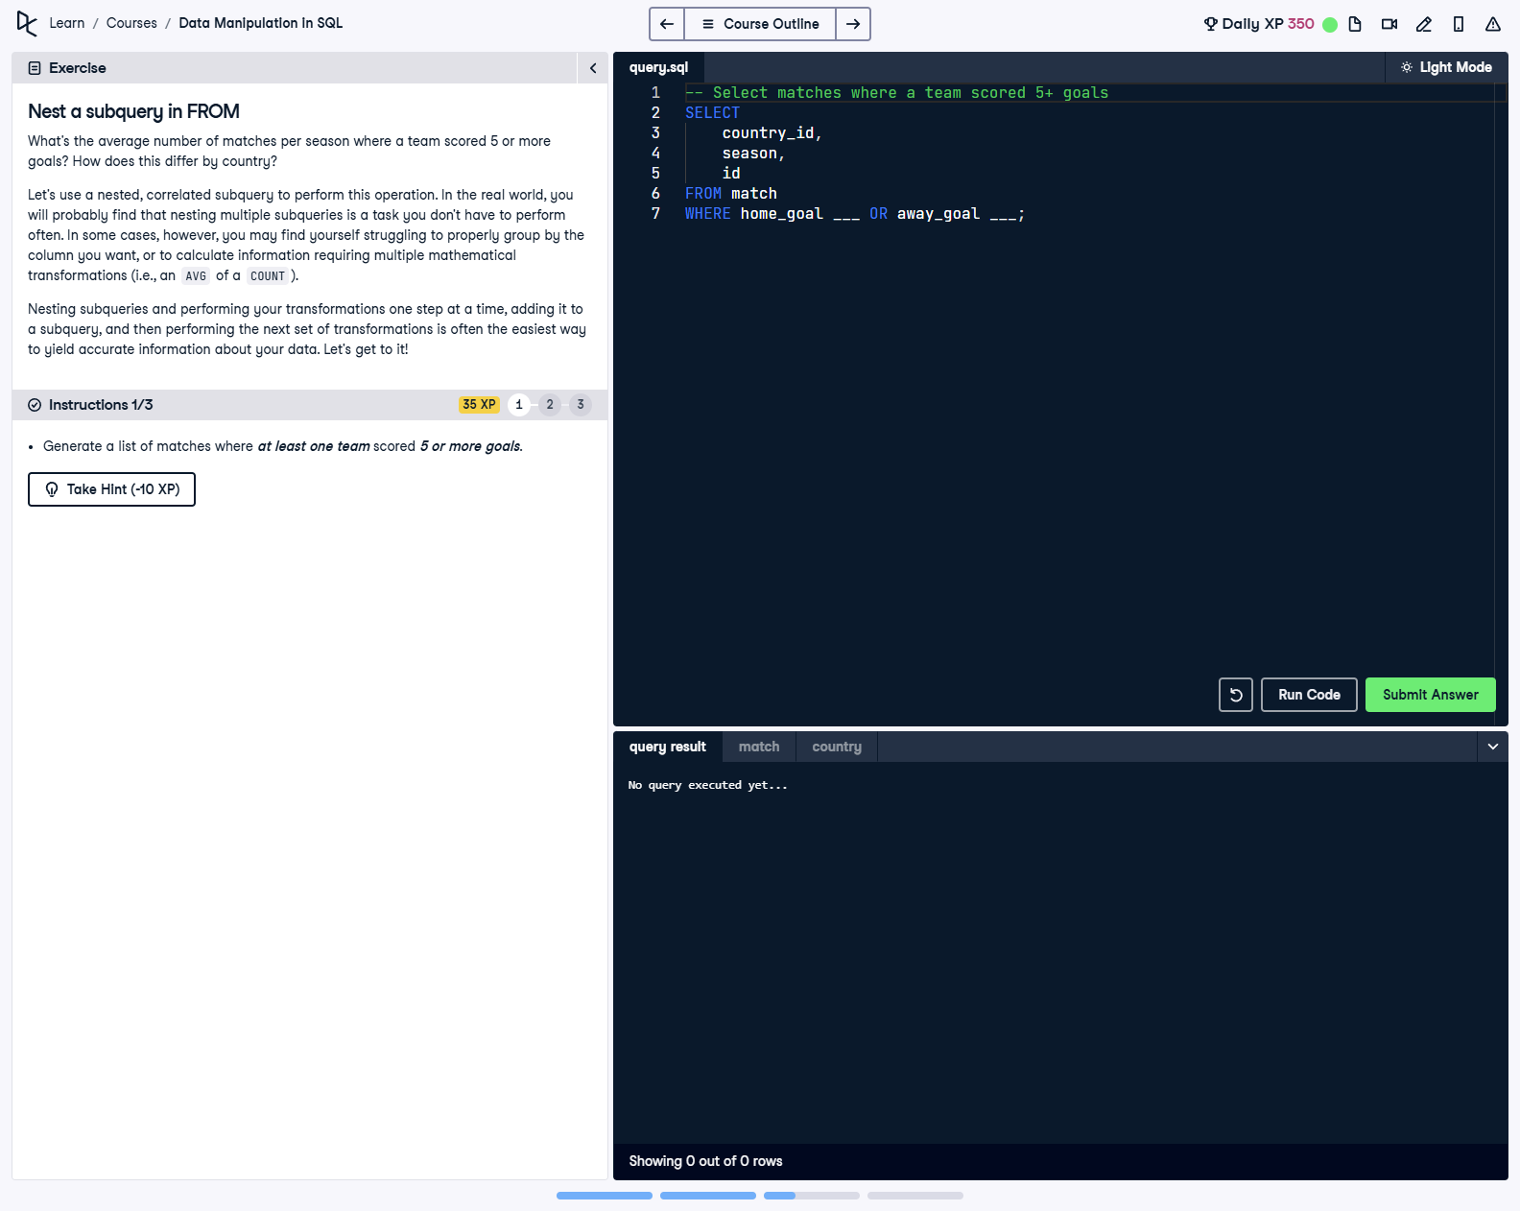

## Question

Generate a list of matches where at least one team scored 5 or more goals.

## Corrected Solution

SELECT  
 -- Select matches where a team scored 5+ goals  
 country_id,  
 season,  
 id  
FROM match  
WHERE home_goal >= 5 OR away_goal >= 5;

## Explanation

This query retrieves matches where at least one team scored 5 or more goals. The `SELECT` clause includes the `country_id`, `season`, and `id` columns to identify the matches. The `WHERE` clause ensures that only matches where either the home team or the away team scored 5 or more goals are included. This forms the foundation for further analysis, such as nested subqueries.